Congo, Rep.

## Population Data

The data set shows the political stability estimate of the country each year.

## # A tibble: 23 x 5  
## country iso3c date population popCategory5  
## <chr> <chr> <dbl> <dbl> <chr>   
## 1 Congo, Rep. COG 1996 2785810 very small   
## 2 Congo, Rep. COG 1997 2867280 very small   
## 3 Congo, Rep. COG 1998 2951647 very small   
## 4 Congo, Rep. COG 1999 3038433 very small   
## 5 Congo, Rep. COG 2000 3127411 very small   
## 6 Congo, Rep. COG 2001 3217933 very small   
## 7 Congo, Rep. COG 2002 3310387 very small   
## 8 Congo, Rep. COG 2003 3406922 very small   
## 9 Congo, Rep. COG 2004 3510468 very small   
## 10 Congo, Rep. COG 2005 3622775 very small   
## 11 Congo, Rep. COG 2006 3745141 very small   
## 12 Congo, Rep. COG 2007 3876119 very small   
## 13 Congo, Rep. COG 2008 4011486 very small   
## 14 Congo, Rep. COG 2009 4145391 very small   
## 15 Congo, Rep. COG 2010 4273731 very small   
## 16 Congo, Rep. COG 2011 4394844 very small   
## 17 Congo, Rep. COG 2012 4510198 very small   
## 18 Congo, Rep. COG 2013 4622761 very small   
## 19 Congo, Rep. COG 2014 4736974 very small   
## 20 Congo, Rep. COG 2015 4856095 very small   
## 21 Congo, Rep. COG 2016 4980999 very small   
## 22 Congo, Rep. COG 2017 5110702 small   
## 23 Congo, Rep. COG 2018 5244363 small

# Population growth data

## # A tibble: 23 x 5  
## country iso3c date popGrowth popGrowthCat5   
## <chr> <chr> <dbl> <dbl> <chr>   
## 1 Congo, Rep. COG 1996 2.85 high growth rate   
## 2 Congo, Rep. COG 1997 2.88 high growth rate   
## 3 Congo, Rep. COG 1998 2.90 high growth rate   
## 4 Congo, Rep. COG 1999 2.90 high growth rate   
## 5 Congo, Rep. COG 2000 2.89 high growth rate   
## 6 Congo, Rep. COG 2001 2.85 high growth rate   
## 7 Congo, Rep. COG 2002 2.83 high growth rate   
## 8 Congo, Rep. COG 2003 2.87 high growth rate   
## 9 Congo, Rep. COG 2004 2.99 high growth rate   
## 10 Congo, Rep. COG 2005 3.15 high growth rate   
## 11 Congo, Rep. COG 2006 3.32 high growth rate   
## 12 Congo, Rep. COG 2007 3.44 high growth rate   
## 13 Congo, Rep. COG 2008 3.43 high growth rate   
## 14 Congo, Rep. COG 2009 3.28 high growth rate   
## 15 Congo, Rep. COG 2010 3.05 high growth rate   
## 16 Congo, Rep. COG 2011 2.79 high growth rate   
## 17 Congo, Rep. COG 2012 2.59 high growth rate   
## 18 Congo, Rep. COG 2013 2.47 moderate growth rate  
## 19 Congo, Rep. COG 2014 2.44 moderate growth rate  
## 20 Congo, Rep. COG 2015 2.48 moderate growth rate  
## 21 Congo, Rep. COG 2016 2.54 high growth rate   
## 22 Congo, Rep. COG 2017 2.57 high growth rate   
## 23 Congo, Rep. COG 2018 2.58 high growth rate

## Population trend

The plot shows the population trend of the country.

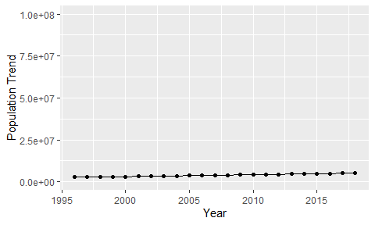

Political Stability Trend

# Population growth trend

The plot shows the population growth rate trend of the country.

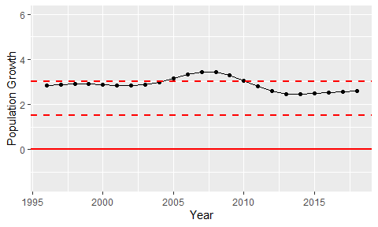

Population Growth Trend